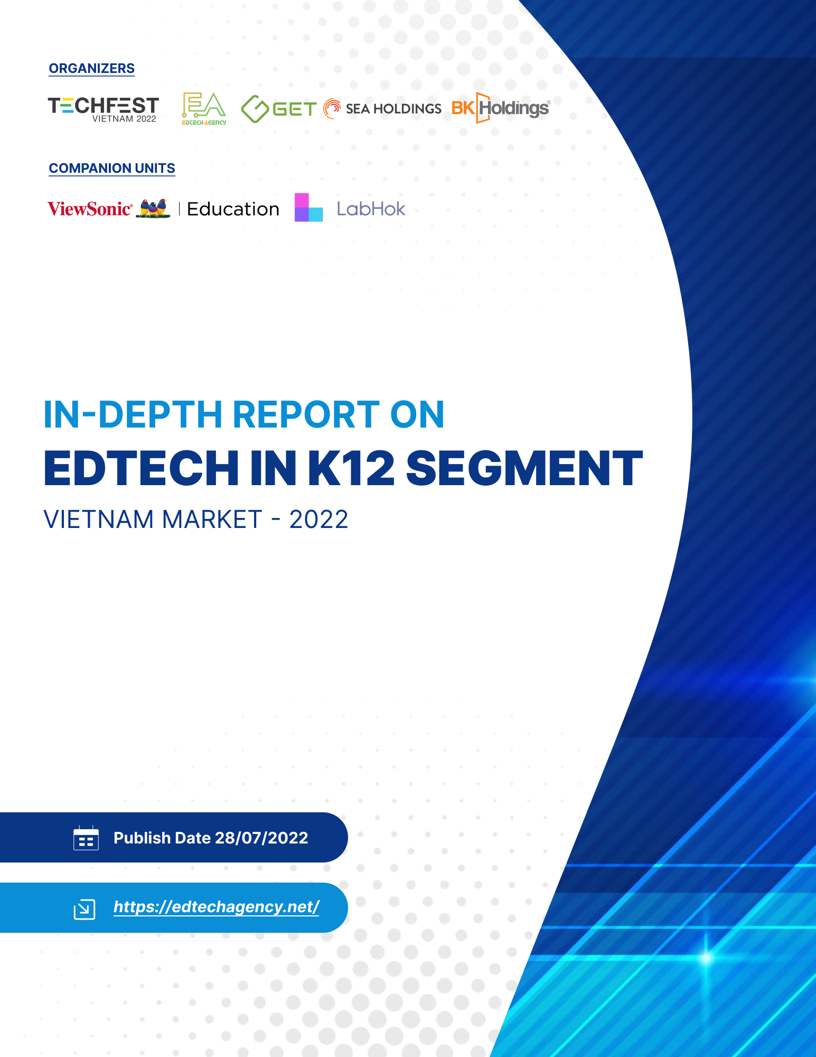

Copyright
All right reserved.
Please note that, apart from internal use and storage by our clients, no part of this document may be reproduced or translated, stored in a retrieval system, or transmitted in any form, or by any means, electronic, mechanical, photocopying, recording or otherwise, without the prior written permission of
…………...

© ---------- 2022
INTRODUCTION
1. About Company
Founded in California, ViewSonic is a leading global provider of visual solutions and conducts business in over 100 countries worldwide. As an innovator and visionary, ViewSonic is committed to providing comprehensive hardware and software solutions that include monitors, projectors, pen displays, commercial displays, All-in-One LED displays, ViewBoard interactive displays, and myViewBoard software ecosystem. With over 35 years of expertise in visual displays, ViewSonic has established a strong position for delivering innovative and reliable solutions for education, enterprise, consumer, and professional markets and helping customers “See the Difference.”

2. About myViewBoard
myViewBoard is an ecosystem of applications and websites within an all-in-one solution for education from ViewSonic. Create new or use premade interactive content for your lesson with a digital whiteboard, present and attend online classes, and share content across devices. Use browser-based tools on myviewboard.com, or download apps on mobile, Windows, Android and macOS.
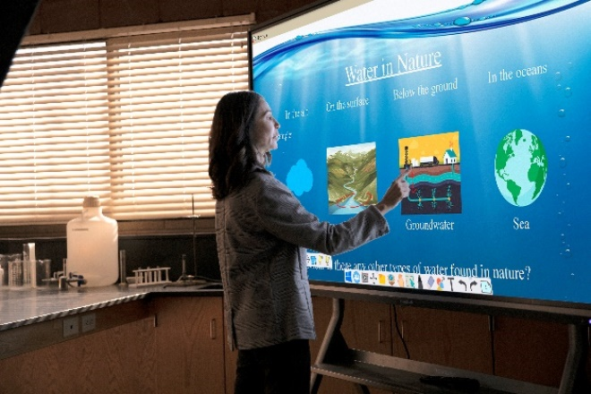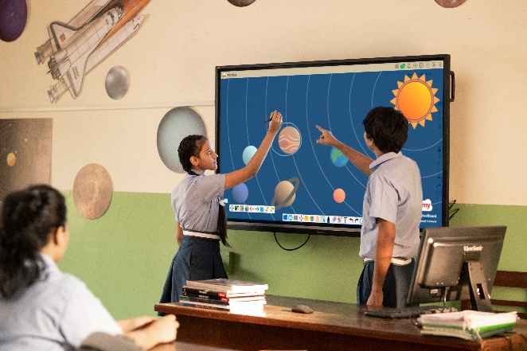

CONTACT INFORMATION
Website: https://www.viewsonic.com/vn/education/
Phone: (+84) 933 924 689
Email: vietnam@viewsonic.com
INTRODUCTION
1. About Company
LabHok is the key to making Teaching, Learning, Assessment and Review easier. LabHok provides schools and teachers with an educational platform to reduce workload, increase teaching efficiency, and understand students' abilities quickly. For Students, LabHok provides an effective self-assessment, mock test and review experience, a solid foundation for them to confidently win the most important exams in their life.
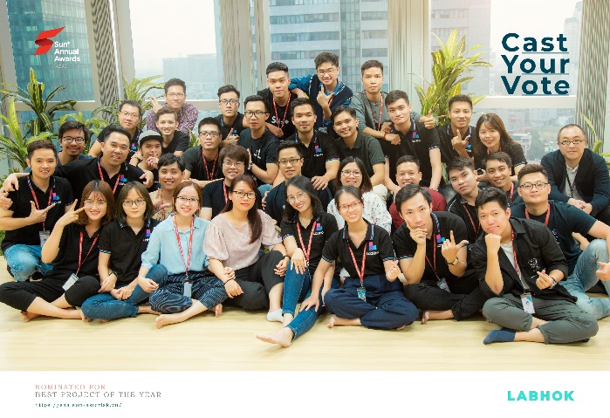

1. Product introduction
- Create test questions, organize exams
- Statistics and student management
- High-quality bank is published and moderated by Hanoi National University of Education and Education Publishing House.
- High School Graduation Mock test and Ability Assessment Mock test.

CONTACT INFORMATON
Website: https://go.labhok.com/
Phone: (+84) 397 589 890
Email: support@labhok.com
TABLE OF CONTENT

INTRODUCTION 1
Part 1. Report overview 2
1.1. Research model 2
1.2. Data collection methods 3
Part 2. Teaching and learning trends in the new normal period 4
Part 3. Educational technology products on the Vietnamese market 6
PART 4 Rank products by market segments 9
Part 5. Policies to support the development of educational technology products in Vietnam 14
Part 6. Suggestions and Trends 18

INTRODUCTION
As a result of the COVID-19 pandemic, in many parts of the world, teachers are forced to teach online without any preparation. The pandemic has led to a sudden shift in modalities without warning or advice on how instruction should be conducted online.
EdTech is a combination of education and technology, using technological tools to improve efficiency in management, teaching organization, and education quality. In recent years Edtech in Vietnam has exploded and become an area of great interest. According to Tracxn Technologies, there are about 260 edtech enterprises in Vietnam, most of which are startups and B2C businesses. EdTech startups in Vietnam are now attracting the interest of domestic and foreign venture capital funds as they bring new business models into the online education and digital transformation in education markets. Investments in EdTech are estimated at $45 million in 2020. South Korea, the US, and Singapore are the leading investors in the market.
In Vietnam, EdTech companies focus on key areas such as SMS, LMS, CLS (including language training), and Steam/ Stem. EdTech systems have now integrated advanced technologies such as augmented reality (AR), virtual reality (VR) and artificial intelligence (AI), etc. Currently, there are more than 70% EdTech products in the market for K-12, with about 23.5 million students, according to the Ministry of Education and Training's 2021 statistics, accounting for 23% of Vietnam's population [8]. Therefore, the EdTech market in Vietnam is estimated to exceed 3 billion USD by 2023 and is evaluated as extremely potential, with total investment in startups ranked 3rd with 20.2 million USD of the total technology sector today, among the top 10 EdTech markets with the fastest growth rate in the globe at about 44.3%.
This report provides a panoramic view of the market of EdTech Vietnam products for the K-12 block, the development trend of product lines for the K-12 block in the market along with in-depth analysis of each separate product segment. The highlight is the ranking of EdTech products through the combination of an automatic ranking algorithm along with the expert panel, which increases the accuracy of the rankings. These are also suggestions for using products and ways for EdTech Start-up through standard criteria to upgrade products and services in line with current market trends to attract more opportunities to receive investment from major funds around the globe.

Part 1. Report overview
  - Research model
This report is based on the SWOT analysis model to assess environmental factors, socio-political conditions, and internal conditions, as well as the strengths and weaknesses of EdTech products for K12 in the Vietnamese market.
This report applies qualitative and quantitative research methods through primary and secondary data. Secondary data is collected from statistical reports of the World Bank, Vietnam General Statistics Office, Vietnam Ministry of Education and Training, national reports of the Asian Development Bank, and other reputable sources. In addition, primary data is also collected through the market, websites, and information sites on the network that can be verified through the registrar's domain name.
Quantitative methods apply evaluation models and algorithms with values collected from reliable systems around the world to serve the product rating to ensure transparency and clarity.
This report presents an expert approach through in-depth evaluation and analysis of each market segment of K12 products to make product suggestions and produce final rankings.
TPACK model
TPACK Framework (2006) by Punya Mishra and Matthew J. Koehler proposes focusing on technological knowledge (TK), pedagogical knowledge (PK), and content knowledge (CK) to provide an effective approach for teachers when implementing educational technology (EdTech) in the classroom. By distinguishing between these three types of knowledge, the TPACK framework outlines how content (what is being taught) and pedagogical methods (how teachers deliver the content) must form the basis for any EdTech model. This order is significant since the technology being implemented must provide the content and support pedagogical methods to improve the learning experience of students.
According to the TPACK framework, specific technology tools (hardware, software) are used to guide students to better and more firmly understand this topic. Therefore, three types of knowledge - TK, PK, and CK- are combined in different ways in the framework of TPACK. Technological pedagogical knowledge (TPK) describes the relationship and interaction between technological tools and specific pedagogical practices, while pedagogical content knowledge (PCK) describes the similarity between pedagogical practices and learning objectives; technological content knowledge (TCK) describes the relationships and intersections between technologies and learning objectives. These triangular areas then form TPACK, which considers the relationships between both types of areas and acknowledges that educators interested in educational technology are operating in this complex associative space.
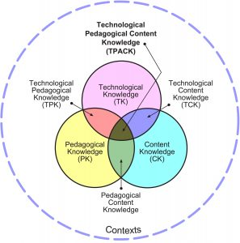

  - Data collection methods
- Desk research
Perform data aggregation based on available sources:
• Internal sources: From the report of the EdTech Agency, the yearbook of the educational technology village seminar
• Sources of information from the Ministry of Education and Training, reputable organizations;
• Information sources from the Internet (website...)
- Quantitative data collection
Data for the quantitative research of this report is collected from several reliable website sources for each product for measurement and evaluation analysis.

Part 2. Teaching and learning trends in the new normal period
K12 education in Vietnam is a significant and integral part of the national education system, carrying out the mission of improving people's wisdom and discovering and fostering aptitudes and talents, which is an indispensable foundation for vocational and higher education. General education includes primary education, lower secondary education (secondary) (primary education stage), and upper secondary education (upper secondary - vocational education stage). Regarding secondary and high education, there are numerous changes in the structure of the three levels of education; the secondary level is decisive in the students' future career orientation. Therefore, investing in the facilities of this level also means orienting towards the training objectives.
In the school year 2021 – 2022, the total number of K12 schools in Vietnam is 26,000, with more than 23 million students [8]. There is a clear difference in the number of schools for lower and upper secondary levels. In recent years, many indicators of general education in Vietnam have been appreciated in the region, focusing mainly on primary education: The enrollment rate of 6-year-old children in the first grade reaches 99% (2nd in ASEAN, after Singapore); The percentage of students attending and completing primary education after 05 years reaches 92.08%, at the top of the ASEAN block; The primary learning outcomes assessment program of Southeast Asian countries (SEA PLM) in 2019 shows that Vietnam's primary students are at the top of ASEAN countries in all 03 surveyed competencies such as Literacy, Writing, and Mathematics.
Online learning systems in the form of LMS have been developed in Vietnam since the early 2007s. Since 2014, they have been developed more diversified, and the information technology skills of teachers and students have been improved. With the development of technology, devices such as smartphones are increasingly used. According to statistics in 2020, the smartphone usage rate in Vietnam ranked 9th in Southeast Asia at 63.1%, higher than Indonesia (58.6%) and the Philippines (37.7%). Vietnam is also considered one of the 20 countries with the highest Internet usage rate in the world, with 68.17 million users (accounting for 70% of the population). About 94% of Vietnamese users use the internet regularly, with an average usage time of up to 6 hours per day.
Currently, in Vietnam, there are several LMS providers. However, in general, they are divided into two types: open source LMS and commercial LMS.
Since March 2020, due to the impact of the Covid epidemic, almost 100% of K12 schools in Vietnam have switched to online teaching. With a large number of classes, it seems that paid software is not an option for many schools. As a result, many schools have opted for e-learning platform solutions such as Zoom Meeting, Google Meet, and Microsoft Teams. For the most part, K12 schools use the Microsoft Teams platform with Microsoft support for educational institutions (68%), Zoom (9%), and Google Meet (23%), marking the readiness to use technology systems applied to improve quality and learning in Vietnam.
In Vietnam, materials management products, teaching, and learning applications are being applied in various types of education: language, knowledge and skills training, exam (K-12), skills and personality tests, and foreign language learning platforms, ...

Part 3. Educational technology products on the Vietnamese market
Education technology (EdTech) in Vietnam today inherits a lot from the world of education technology. In addition to the products of foreign companies imported into Vietnam, domestic companies also gradually affirmed the position of their products in the home market. Education technology companies in Vietnam have witnessed an extensive increase in new business registrations in the last two years. In particular, many Vietnamese companies have experience developing products and transforming learning models to suit the economic and educational conditions of domestic schools. Major software companies have also gradually moved to products for Edtech, including major Edtech product and service providers such as FPT, Viettel, and VNPT. FPT is rapidly becoming a leading edtech company. FPT's application uses artificial intelligence (AI) technology to tailor the learning experience to the individual needs of each student. The EQuest Education Group focuses on teaching English and digital education to a globally competitive workforce. Previously, online teaching applications and platforms such as CoderSchool, Marathon, Elsa, AI Clevai, etc. invested millions of dollars to participate in a race to attract users. A segment of Vietnamese companies now dominates the domestic education technology market. LeGia Group is a leader in providing modern and innovative solutions& training around the world. Providing and conducting a central experience in VR, AR, etc. are applied in many fields of education, entertainment, advertising, entertainment... LeGia Group offers a variety of product lines such as Virtual Reality Education Solutions in Schools, Virtual Lab Apps, Drawing and Creative Apps in 3D Spaces, 3D / VR Spatial Design Apps, and Scratch Shapes. Green Universal Education Technology Joint Stock Company with assignment and grading software, Azota, the online school platform WEWIIN supports blended learning for the first time in Vietnam. WEWIIN owns state-of-the-art facilities to optimize the management process and enhance the quality of training. OMT has built and developed a set of products and services for education, including KidsOnline, CenterOnline, SchoolOnline, and OMT Education...
The digital content market is now of interest in Vietnam, with service providers offering several products, such as English language courses and game-based learning content for early childhood education, exam practice, self-study options, e-books, and the search for tutorial services for general education. A notable foreign company in this segment is Snapask, a startup based in Hong Kong that entered Vietnam in 2020 and offers tutoring applications to education students. There are numerous English teaching products for students and adults, such as Elsa or Duolingo. Some local edtech companies have also tried to diversify their product content into other skill development areas such as Mathematics. It is in line with the growing desire of Vietnamese parents for their children to develop STEM skills. CoderSchool, a startup providing online programming training, raised the US $2.6 million in a Pre-Series A funding round led by Monk's Hill Ventures.
Regarding LMS platform provider for school management, teaching and learning innovation, tutoring and assessment services, etc. Leading companies are offering this solution in Vietnam, including Wewiin, Ai Vietnam, and Topica Group. Currently, there are nearly 300 universities in Vietnam, including 22 universities offering distance training programs, applying eLearning as one of the methods of organizing, implementing, and managing the training process.
Products providing school management systems (SMS) are developed according to the school level segments, such as Kidsonline, SMASS, OneEdu... The products of major technology companies such as MS Teams, and Google Education are commonly used in Vietnam to enable the integration of many school lecture resources to support teaching, integrating online interactive tools and solutions (MS Teams provides easy and convenient email for manipulation, Google with fully integrated email tools, interactive classes, Google Meet and Google Drive... is currently widely used for K12 education in Vietnam).
Elearning online training system developed from Moodle core also allows integration of email tools, and online teaching tools such as Zoom, Bigbluebutton, and MS Teams. School administration systems with support for online teaching and integration with users' email phone numbers are also used in schools in Vietnam: kidsonline, oneEdu,...Tools to support the development of lectures include Adobe presenter, Ispring suite,...and other supporting tools such as Test Bank, Azota,...
New technologies, applied AI, VR/AR in the Vietnamese market today are largely developed by large technology companies that can integrate or support online training systems including online exam monitoring systems with AI monitoring such as Examus, a lecture repository of experimental practice simulation for K12 block with VR/AR technology such as Scholar, or 3D simulation repository such as PhET, Openclassroom, etc. Besides, the STEAM/stem education segment developed in Vietnam in recent years has focused mainly on K12 to improve technological knowledge for students, also opening up new prospects with the leadership of some companies such as Vinarobot, and Sunbot...
However, the education technology market in Vietnam is still relatively new and young, and EdTech products currently only meet a small part of customers' demand. Although there is great potential for development and diverse product types, the product quality and the distribution between types are not even. The educational technology platforms developed for schools, businesses, etc., are relatively new and not strongly promoted. More than 80% of EdTech units in Vietnam are focusing on K12 and Foreign Language markets. In each segment, the products have many similarities, not making any difference, imprint, or distinctive value. This market is mainly for technology units penetrating education, so they are not experienced, not deep in features and content.

PART 4 Rank products by market segments
4.1 Reasons to rank K12 products
Rating standards hold significant positions for product development, aiming at the following purposes:
- Rating standards aim to improve the quality of service to users, ensure the interests of users, and as a basis for users to know and manage the quality of services they enjoy. This is the purpose of the rating standard to attract and develop potential users to develop products at a fast pace.
- Rating standards serve as the basis for developing other specific technical standards such as system design and content standards.
- Rating standards to ensure uniformity and quality.
- Rating standards are the basis for managers, and investors to supervise and approve economic, technical, and financing arguments for the construction and upgrading of old systems, and serve as a basis for checking and monitoring the system quality.
- Rating standards serve as a basis for determining the price of services and developing appropriate price policies for each segment and each type of product.

4.2. Rating method
The TPACK model is a suggestion for the rating method given in this report. This report presents an improvement of the TPACK model for ranking using the algorithm for K12 products. These are the criteria for measuring, evaluating, and using specific values to create an automatic ranking formula for educational technology products for the K12 block. First, the separation between 03 interference blocks includes:
- Technological criteria
- Criteria for content
- Criteria for domain value (as an alternative to pedagogical measurement)
Technological criteria ensure that the product is good in terms of technology because when the number of visitors is large, the system can still operate stably. Content criteria indicate a steady or steadily increasing access in the last 6 months. Attracting more visitors and consistently showing that the content fits the issue they're looking for. The criteria for domain value are website ranking.
The method of rating educational technology products for K12 in Vietnam's market is carried out according to the following steps:
(1). Collect data on K12 products of the entire Vietnamese market and compile them into the official list after eliminating the products that are not built and developed by Vietnam.
(2). Use the Neipatel system to retrieve access data for products within the last 06 months. This report uses data from November 2021 to March 2022.
(3). Use Alexa ratings to get domain criteria values.
(4) Summarize the criteria to calculate the weight of each product according to the formula:
$$Score\left({Product}_{i}\right)=α*Tech+β*Content+γ*Web_Ranking$$
Therein:
- $Score\left({Product}_{i}\right)$: The measured value of the product ranked at the i position in the rating
- Tech: Measured value of product i's technology criteria
- Content: Measured value of product i's content
- Web_ranking: Measured value of the website
- $α$, $β, γ$: Are the respective coefficients and $α$+ $β+ γ$=1
4.3 Ranking Results for K12 block
K12 block products are classified into five main product groups. These are the five most popular product groups in the Vietnamese market today. These products are categorized by features including:
- Platform solutions and tools: The product group provides platforms to support the construction of lectures, development of learning metrics, online tutoring, online schools similar to LMS, etc.
- Create, develop, and sharing of content: The group of products provides the content of lectures and learning materials.
- Foreign language training and dissemination: Group of foreign language training products
- Stem/Steam education: Product group training on STEAM/stem, VR/AR,...
- Examine and evaluate: Group of products to guide the review, examination for transfer...
For each product group, the ranking will select the 20 products with the highest score. A list of ranking by product groups is listed below.

Platform solutions and tools
No. | Name of Product | directory_contact__website
 | Smas Viettel | https://smas.edu.vn/Home/LogOn?ReturnUrl=%2f
 | SHub Classroom | shub.edu.vn
 | Vnedu | https://vnedu.vn/
 | vio | https://vio.edu.vn/
 | Violet | violet.vn
 | K12online | https://k12online.vn
 | Hocmai | https://hocmai.vn/
 | 789 | https://www.789.vn/
 | Azota | https://azota.vn/
 | vinastudy | https://vinastudy.vn/de-luyen-online.html
 | Enetviet | https://enetviet.com/
 | Hachium | https://hachium.com/
 | thingkingshool | https://thinkingschool.vn/
 | bigschool | https://bigschool.vn/
 | blacasa | https://www.blacasa.vn/
 | mschool | https://mschool.mobiedu.vn/
 | edubit | https://edubit.vn/
 | edulive | https://edulive.net/
 | Misa QLTH.VN | https://emis.misa.vn/
 | Easy Edu | https://easyedu.vn/

Create, develop and share content
No. | Name of Product | directory_contact__website
 | doctailieu | https://doctailieu.com/
 | vietjack | https://vietjack.com/
 | Loigiaihay | https://loigiaihay.com/
 | hoc247 | https://hoc247.net/
 | phuongtrinhhoahoc | phuongtrinhhoahoc.com
 | OLM | olm. vn
 | Toploigiai | toploigiai.vn
 | Moon | https://moon.vn/
 | Tech12h | https://tech12h.com/
 | hoidap247 | https://hoidap247.com/
 | tuhoc365 | https://tuhoc365.vn/
 | Vungoi | https://vungoi.vn/
 | hoc24 | https://hoc24.vn/
 | cunghocvui | cunghocvui.com
 | Sachgiaibaitap | sachgiaibaitap.com
 | giaibaitap123 | https://giaibaitap123.com/
 | timdapan | timdapan.com
 | metaisach | metaisach.com
 | mathvn | mathvn.com
 | hayhochoi | https://hayhochoi.vn/

Training and dissemination of foreign languages
No. | Name of Product | directory_contact__website
 | stepup | https://stepup.edu.vn/
 | goioe | https://ioe.vn/
 | studytienganh | studytienganh.vn
 | tienganhmoingay | https://tienganhmoingay.com/
 | Tienganh123 | https://www.tienganh123.com/
 | ejoy-english | https://ejoy-english.com/vi/
 | engbreaking | engbreaking.com
 | Voca | https://www.voca.vn/
 | mshoagiaotiep | https://mshoagiaotiep.com/
 | Yola | https://yola.vn/
 | Dungmori | https://dungmori.com/
 | Monkey | https://monkey.edu.vn/
 | kidsup | https://www.kidsup.net/
 | Tata | http://tata.edu.vn/
 | Lingobee | https://lingobee.vn/
 | Yotalk | yotalk.edu.vn
 | Ekid | https://ekidenglish.edu.vn/
 | Holospeak | https://holospeak.vn/
 | i-learn | http://i-learn.vn/
 | E-study | https://estudy.langmaster.vn/

STEAM/STEM Education
No. | Name of Product | directory_contact__website
 | teky | https://teky.edu.vn/
 | Stem for Vietnam | https://www.steamforvietnam.org
 | ohstem | https://ohstem.vn/
 | stemhouse | https://stemhouse.edu.vn/
 | STEMZone | https://stemzone.vn
 | iTRainKids | https://itrainkids.vn
 | STEAM Academy | https://steamacademy.edu.vn/
 | Stem Academy | http://hocvienstem.com
 | Robotstem | http://robotstemtpa.vn/
 | Vietrobot | http://www.vietrobot.edu.vn/
 | Kidscode | https://www.kidscode.edu.vn
 | codekitten | https://codekitten.vn/
 | Garastem | https://garastem.com/
 | Vinarobot | https://vinarobots.com/
 | STEMGO | https://stemgo.vn
 | StemSquare | http://www.stemsquare.vn/
 | MAGICSTEM | https://magicsteam.vn
 | Stemax | https://stemax.vn
 | Creative Academy Joint Stock Company | https://hocviensangtao.edu.vn
 | Trung tâm STEM Petrus | https://stempetrusky.edu.vn

Testing, evaluating
No. | Name of Product | directory_contact__website
 | Onluyen.vn | https://www.onluyen.vn/
 | trangnguyen | https://trangnguyen.edu.vn/
 | tuyensinh247 | https://tuyensinh247.com/
 | Luyenthi123 | https://www.luyenthi123.com/
 | dethikiemtra | https://dethikiemtra.com/
 | thiquocgia | https://thiquocgia.vn/
 | cungthi | cungthi.online
 | luyentap247 | luyentap247.com
 | Dethihocky | https://dethihocki.com/
 | luyenthithphquocgia | luyenthithptquocgia.com
 | lop12edu | lop12.edu.vn
 | onthitracnghiem | https://onthitracnghiem.online/
 | Onthidaihoc247 | http://www.onthidaihoc247.com/
 | Testbank | https://testbank.vn/
 | Thivao10 | https://thivao10.net/
 | Practice exam PRO | https://luyenthipro.com/
 | onthi247 | https://onthi247.vn/
 | Onluyen.vn | https://app.onluyen.vn/login
 | EMIS review | https://sisap.vn/lms/account/login
 | school.onluyen | https://school.onluyen.vn/login

Part 5. Policies to support the development of educational technology products in Vietnam
The application of information technology in education is encouraged by the Government of Vietnam to enhance the skills of teachers and students to use information technology and, at the same time, improve the quality of teaching. School management systems and student management systems have been widely used since the early years of the 21st century.
Since 2015, the Government of Vietnam has issued several decisions and circulars guiding distance training on the online training system [1], [2]. During this time, Topica online training systems were developed, contributing to the training of thousands of remote university students annually. In addition, the Ministry of Education and Training also issued regulations on the IT competence of lecturers to meet the requirements of IT skills in the new period [3]. A number of IT application products during this period developed by large companies such as Google or Microsoft also supported educational institutions in Vietnam under the introduction of the Ministry of Education and Training in operating schools.
In 2020, due to the influence of Covid, the Government of Vietnam issued new policies on online training. Accordingly, it recognizes the process of online teaching and online examinations and recognition of international cooperation in online training [4]. At the same time, bachelor programs of universities are also allowed to provide online training for 30% of the total credits. In addition to the above policy, the Ministry of Education and Training of Vietnam has introduced MS Team products for the Department of Education and free use in teaching in K12 during Covid-19.
In 2022, the Prime Minister issued Decision 131/QD-TTg [5] approving the Project "Strengthening the application of information technology and digital transformation in education and training in the period 2022 – 2025, orientation to 2030", clearly showing the determination of the Government of Vietnam in the digital transformation of the entire education sector. Accordingly, by 2025, the proportion of online classes at training levels will reach 5%-20%.
In early 2022, the Government issued the Decision "Approving the national strategy for the digital economy and social development to 2025, orientation to 2030" [6] and adopted the national program on digital transformation to 2030. Digital transformation is also prioritized in eight areas including finance and banking, health, education, agriculture, transport, logistics, energy, natural resources, and the environment and manufacturing. In particular, digital transformation in education is considered a key area.
According to the orientation of the Government, the digital transformation in the education sector towards 2025 will bring 50% of teaching and learning to the digital environment. It is necessary to establish several online teaching and learning platforms as domestic products, which are used by more than 50% of students; to establish a national online learning repository to meet the requirements of learning materials for 50% of the content of general education programs; more than 50% of higher education institutions provide remote and online training programs.
The definition of EdTech is not clear in Vietnamese legal documents. However, the proposals on the application of information technology and policies to support software technology companies are quite effective. The Government has incentives tax policies for software development companies, including production of digital information content products, software services, key IT products, information security troubleshooting services, information security protection, and corporate income incentives tax such as those currently applied to software product production projects under the provisions of the Law on Corporate Income Tax. In addition, there is a policy to reduce 50% of personal income tax on salary and remuneration of high-tech individuals working in the IT sector. In the case of new investment projects in the field of IT, the above-mentioned investment should be particularly encouraged with the recurrent use of more than 1,000 employees, extended by the period of application of the tax rate of 10% for 15 years.
The development trend of education in the future of Vietnam (in which the educational technology market plays a driving role) is extremely vibrant and attractive. More than just a playground for Startups, EdTech is increasingly an attractive investment target for large investors and venture capitalists.
In addition to the national start-up competitions, schools, and research institutes, over time, the Ministry of Science and Technology has also always accompanied and supported the Educational Technology Village to access new technological information, connect and bring together the major educational technology companies in Vietnam. In addition to the National Startup Support Fund, Vietnam also has venture capital funds provided by domestic organizations and enterprises such as Bkholding, Vietnam Science and Technology Enterprise Startup Fund...
The potential for entrepreneurship, support from macro factors, and attractive pricing make Vietnam an attractive investment destination in terms of EdTech, attracting many foreign investment funds to the market. Up to now, investment in technology start-ups in Vietnam has mainly come from abroad. Foreign investors consider Edtech Vietnam as fertile land that can be exploited, Redefine Capital Fund (Singapore) - an investment fund backed by Alibaba and Ant Financial that invests in Start-up Educa has just received $2 million in Series A funding rounds. Venture Capital Fund Do Venture invests in online education platforms Vuihoc and Manabie. The KKR investment fund poured $100 million into the Equest Education Group.
Investing in Edtech Vietnam
In recent years, a significant number of investors have shifted their focus to the education sector in search of more opportunities in Vietnam, especially in the EdTech market, which is still in the early stages of development. It is estimated that the EdTech market in Vietnam could reach $3 billion. In addition, Vietnamese authorities have promoted E-learning initiatives, making parents and students more interested in online learning and digital resources. Online education in Vietnam has great prospects with more than 23 million students, increased middle-class income, and a high Internet usage rate of over 70% of users. The Vietnamese spend up to 30% of their disposable income on education and parents are willing to pay extra to ensure high-quality education for their children.
The Vietnamese Edtech market is ranked in the top 10 fastest Edtech growth rates in the world. In Vietnam, Edtech ranks third in terms of attracting investment capital. Total venture capital in this sector in 2019-2020 was $103 million, just behind payments ($462 million) and retail ($416 million).
Start-up educational technologies in Vietnam also attract many domestic and foreign venture capital funds thanks to their high development potential. Many educational technology startups have raised quite large amounts of capital such as Topica Edtech ($50 million), ELSA English learning app with $5 million co-financed by Vietnam Investments Group, and SIG, CoderSchool has raised $2.6 million from Monk's Hill Ventures. MindX has raised $3 million in a Series A round by Southeast Asian company Wavemaker Partners, Vietnam investment bank Thien Viet Securities, and a US-based investor. Clevai raised $650,000 USD in 2020 from BOD Tech Ventures. In 2021, Clevai obtained an additional US $2.1 million from Altara Ventures due to being based in Singapore. Vietnam is a potential market for e-learning, but no major edtech companies are valued above $100 million. Meanwhile, some edtech unicorns have appeared in India and China. Some suggested that Vietnamese edtech companies still lack breakthrough technologies to improve.

Part 6. Suggestions and Trends
The increasing demand for online learning has also spurred Vietnam's educational technology market to grow. According to predictions, the Vietnamese EdTech market is currently worth 3 billion dollars. Currently, there are about 200 EdTech startups in Vietnam– it is also in the top 5 countries receiving investments in education technology. With supporting and initiatives policies for both EdTech and startups, Vietnam undoubtedly has great potential to grow the edtech market due to the following reasons:
- Education is one of the priority sectors for development and one of the areas of determination for a comprehensive digital transformation in the roadmap to 2030.
- Education is one of the top priorities of Vietnamese parents. They are willing to make big investments to enable their children to learn. Continuing education also plays an important role in lifelong learning.
- The rate of access to technology of people is high, and the rate of using smartphones and Internet access is extensive.
- Vietnam has an information technology development strategy, striving to become a strong IT country in the region.
- The software technology industry and technology startups receive great support from government policies such as taxes and incentives for investment opportunities.
- Vietnam's K-12 education system is extensive, with about 23 million students in a variety of schools: ethnic, semi-public, public, and international... offering promising opportunities for EdTech products and services.
- The government of Vietnam has undertaken significant reform of the education system, seeking to improve the quality of Vietnam's educational human resources to international standards.
Potential business opportunities for EdTech partners include:
- Focus on digital products:
  - Develop digital tools/ solutions on mobile devices, and new core technologies: AI, Block Chain, adaptive learning, and deep learning,... based on which will be adjusted to suit each unit and educational institution.
  - Developing digital content and changing thinking when developing with innovative materials, attracting all subjects and stakeholders in the field of education (co-participation).
  - Integrate stem/STEAM training content into Vietnam's current curriculum.
  - Invest in e-Library, and e-Books according to the national general standard program. Develop open educational resources (OER).
- Develop digitized activities in education and teaching management, and software to connect parents, community, and society:
  - Communication, interaction on digital platforms
  - Storage, management, analysis of system data, integration of shared data axes
  - Functional activities are operated on a synchronous digital platform (planning, implementation organization, executive direction, monitoring inspection...)
  - Digital Integration Services
- Developing a digital business model
  - connection EdTech+EdIn;
  - Develop a smart school model from virtual and physical school platforms.
- Investing in EdTech exchanges
  - Consider adopting flexible business models: sell, lease, rent for a certain time and then resell to the user to optimize business opportunities.
  - Piloting the "Economics of Education" model for EdTechs: creating new, leading, oriented educational products instead of digitizing existing educational models... towards the "Eco Digital Education" model
  - Create differences and core values compared to similar enterprises in the context of increasingly fierce competition between enterprises in the industry. There are many free educational technology applications on the market, and EdTech businesses that want to collect user fees need to show superiority in features over free software.
  - Consider niche products that are part of EdTech's comprehensive development strategy, and develop services that leverage open source and/or low-cost technologies to add value to customers. The EdTech service should be designed as an innovative comprehensive solution, which can vary in scope and variety according to the specific needs of the customer.
To leverage the full potential of the EdTech market in Vietnam, EdTech suppliers need to face and address challenges and barriers such as:
- The time it takes to transform systems and curriculums from regular in-person classroom instruction to virtual education for both individuals and businesses.
- The hesitation of some teachers/instructors in providing online education.
- The perception of many learners is still low on online education.
- Lacking Evidence of market willingness to pay for online courses.
- The need to ensure higher quality (both in technical terms, content, programs, and pedagogy...) in online education.
While the vast majority of Vietnamese are used to free products, many people also started to use the products with a moderate fee but ensuring more usability and post-sales service. Support for the training institutions and the security of the products are concerns by the managers of the training institutions nowadays.
The EdTech app to deliver training in every space and time becomes essential after the Covid 19 pandemic. The Covid-19 pandemic has naturally put a strain on the application of EdTech to the continuing training of educational institutions, businesses and training service providers. Free or low-cost applications are paired into an application tool package for teaching and learning, typically using Zoom, Skype, TeamViewer, GoogleMeet, Microsoft Teams for two-way interaction in images and languages, or Facebook's sreamreamer function for one-way interaction in images and languages and vice versa in typewriting. Especially this interactive technology is extremely useful with large class-scale online training because it does not limit the number of participants and crosses the limits of space and implementation time.
Teaching methods during the pandemic also change the view of learning and self-learning of the majority of Vietnamese. Single applications have now been combined into a package of teaching and learning technologies, creating a more open learning environment for the majority, promoting the ability and motivation of self-study for learners and the ability of teachers to use technology. Learners' self-awareness and teaching technology application skills are the prerequisites for EdTech to thrive.
References
[1]. Decision No. 1559/QD-TTg dated September 10, 2015, of the Prime Minister
[2]. Decision 117/QD-TTg dated January 25, 2017, of the Prime Minister
[3]. Circular No. 03/TT-BTTTT-BGDĐT dated March 11, 2014, of the Ministry of Education and Training
[4] Circular No. 09/2021/TT-BGDDT dated March 30, 2021, of the Ministry of Education and Training
[5]. Decision 131/QD-TTg dated January 25, 2022, of the Prime Minister
[6]. Decision No. 411/QD-TTG DATED March 31, 2022, of the Prime Minister
[7] Circular No. 10/2017/TT-BGDĐT dated April 28, 2017, of the Ministry of Education and Training
[8]. https://moet.gov.vn/thong-ke/Pages/Thong-ke-giao-duc-trung-hoc.aspx

